Main Key Terms
Part One IT Project Management

- Introduction To Project Management
project, project management, project manager (hard and soft skills), stakeholders, triple constraint, Project management knowledge areas, PMI, PMO, PMP

- The Project Management and Information Technology Context
Deliverable, project life cycle, Characteristics of Organizational Culture, systems development life cycle (SDLC), Organizational Structures (Functional, Project, and Matrix)

- Project Management Process Groups: A Case Study
5 process groups, process groups and KAs mapping

- Project Integration Management
project integration management, project charter, project management plan, scope statement, Weighted Scoring Model

- Project Scope Management
project scope management, scope planning, scope control, scope definition, work breakdown structure(WBS), WBS dictionary

- Project Time Management
Activity definition, activity sequencing (FS,SF,FF,SS), activity resource estimating, activity duration estimating, schedule development, schedule control, milestone, Gantt chart, network diagram, critical path, PERT, AOA,(ADM), PDM, types of dependencies between activities

- Project Cost Management
project cost management, earned value management(EVM), cost estimating, cost budgeting, life cycle costing, project's payback period, sunk cost

- Project Quality Management
project quality management, quality assurance, quality planning, quality control, 20/80 Pareto analysis, fishbone diagrams, conformance cost, Nonconformance cost

- Project Human resource Management
Project human resource planning, Acquiring the project team, Developing the project team, Managing the project team, Maslow’s Hierarchy of Needs, Covey and Improving Effectiveness, Myers-Briggs Type Indicator(MBTI), Resource Leveling

- Project Communications Management
Communications planning, Performance Reporting, Managing Stakeholders, Conflict management plan, disseminating project information

- Project Risk Management
Project Risk, Negative risk, Positive risk, Brainstorming, Risk management planning, Contingency plans, Risk identification, Risk register

- Project Procurement management
Project Procurement management, Planning purchases and acquisitions, Conducting contracting (5 steps), Selecting sellers, Administering the contract, Closing the contract, Contract Statement of Work, Types of contracts

Part Two Quality Engineering

- CMMI
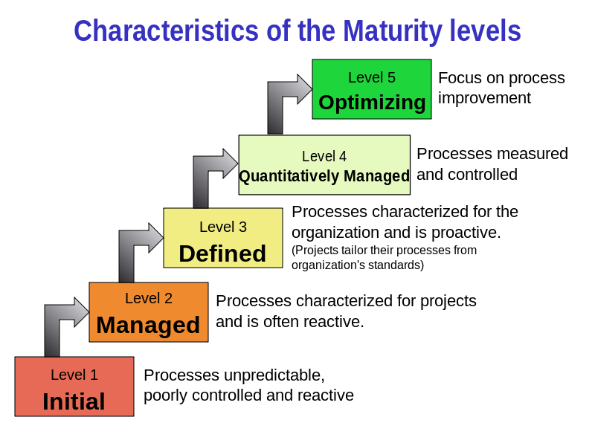

- IOS9001

The types of the final test exercises:
- Single Choice
- Comprehensive Question
- Calculation
- Analysis

